**Design Documentation**

**Predictive Analysis of Open Govt. Data (OGD) Platform India (data.gov.in)**

Made By:

Snehil Ameta

Jatin Garg

Sakshum Sharma

Devendra Pratap Yadav

Simarjeet Singh

* 1. **Use Case Diagram**

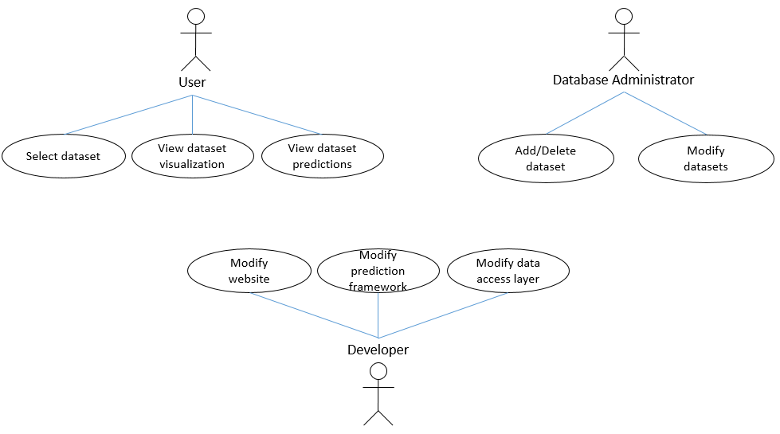

* 1. **Component Diagram**

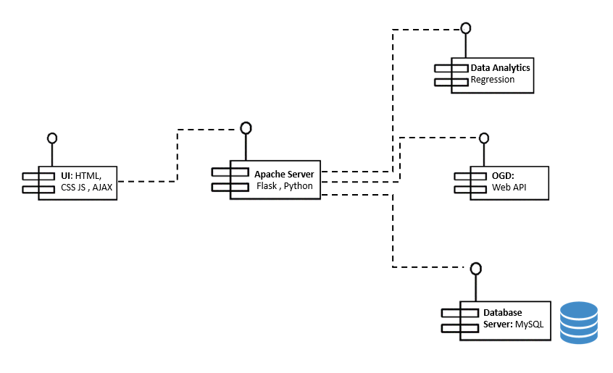

* 1. **Sequence Diagram**

